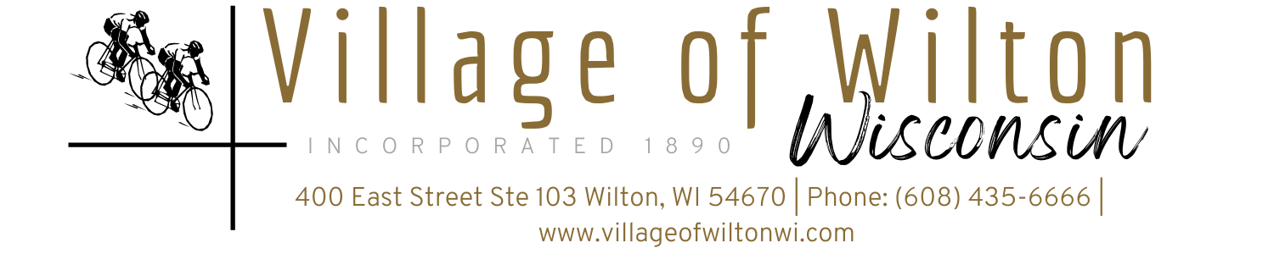

Pursuant to Section 19.84, Wisconsin Statutes, notice is hereby given to the public by the Village President, that the following meeting will be held:

Meeting: | Regular Village of Wilton Board Meeting | Date: | Monday, February 10, 2025
Location: | Village Clerk Office  400 East Street Suite 103 Wilton, WI | Time: | 7:00 PM

AGENDA
A. Call to Order
B. Roll Call
C. Reports of Village Board
a) President’s Report
b) Village Board Comments
c) Village Staff Comments

D. Consent Agenda
a) Bills for the month of January 2025
b) Approval of Minutes

E. Public Comments

F. Discussion & Possible Action on Following New Business Agenda Items:
a) Pay Request No. 19 for WWTF Items
b) Evan Chambers- WWTF Project Change Order and Milestone #1
c) Evan Chambers- Phosphorus treatment and eventual Water Quality Training
d) Outdoor Storage Lot at 1102 Walker St.
e) Total Energy Systems Agreement
f) Employee Committee Policy Recommendation
g) Mattress Disposal Rate Increase

G. Adjourn

Mindy Haase – Clerk Treasurer

Page 1 of 1
Agenda posted in accordance with all Wisconsin State Statutes

