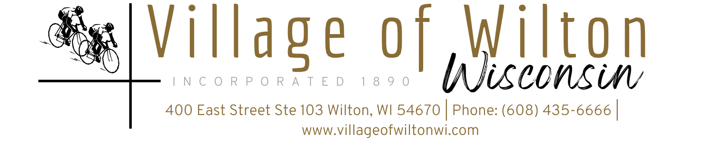

Pursuant to Section 19.84, Wisconsin Statutes, notice is hereby given to the public by the Village President, that the following meeting will be held:

Meeting: | Village Board of Wilton Special Meeting | Date: | Monday, June 23, 2025
Location: | Village Clerks Office  400 East St Suite 103 | Time: | 6:00 PM

AGENDA
- Call to Order

- Roll Call

New Business (Items are for discussion and possible action)

Campground lighting repairs

CMAR resolution

Firework Permit for Wilton Weenie Days

- Adjourn

Mindy Haase – Clerk Treasurer

Agenda posted in accordance with all Wisconsin State Statutes

