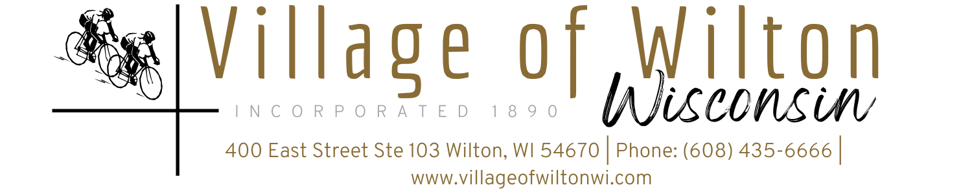

Pursuant to Section 19.84, Wisconsin Statutes, notice is hereby given to the public by the Village President, that the following meeting will be held:

Meeting: | Regular Village of Wilton Board Meeting | Date: | Monday, April 14, 2025
Location: | Village Clerk Office  400 East Street Suite 103 Wilton, WI | Time: | 7:00 PM

AGENDA
A. Call to Order
B. Roll Call
C. Reports of Village Board
a) President’s Report
b) Village Board Comments
c) Village Staff Comments

D. Consent Agenda
a) Bills for the month of March 2025
b) Approval of Minutes

E. Public Comments

F. Discussion & Possible Action on Following New Business Agenda Items:
a) Main Street Floral Baskets- Jim Sommerfield
b) Campground Lighting- Scott Lind
c) Wilton Weenie Days use of grounds
d) Wilton Weenie Days summer volleyball league concession use
e) S&S Concrete estimates
f) Badger Swimpools estimate
g) Opening Date for Campground
h) Campground Advertising- The Visitor, Go Monroe
i) VC3 estimate for IT support
j) New Ambulance Hires- Rhonda Wurster & Phillip Wurster
k) Operator’s License- Ashley Chinnock
l) Boy Scout Service Project
m) Opening of Truck Bids

G. Adjourn

Mindy Haase – Clerk Treasurer

Page 1 of 1
Agenda posted in accordance with all Wisconsin State Statutes

