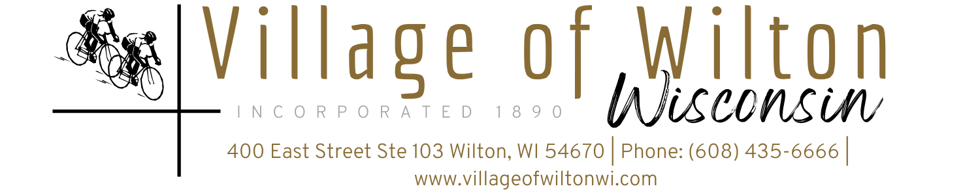

Pursuant to Section 19.84, Wisconsin Statutes, notice is hereby given to the public by the Village President, that the following meeting will be held:

Meeting: | Regular Village of Wilton Board Meeting | Date: | Monday, July 14, 2025
Location: | Village Clerk Office  400 East Street Suite 103 Wilton, WI | Time: | 7:00 PM

AGENDA
A. Call to Order
B. Roll Call
C. Reports of Village Board
a) President’s Report
b) Village Board Comments
c) Village Staff Comments

D. Consent Agenda
a) Bills for the month of June 2025
b) Approval of Minutes

E. Public Comments

F. Discussion & Possible Action on Following New Business Agenda Items:
a) Evan Chambers, Town and Country Engineering- WWTF update
b) Pay Request No. 21 & 22 for WWTF Items
c) Liquor License Renewal- Wilton Leasing-400 Main Street, Wilton- Eli Yoder-Agent
d) Vehicle Vendor License- Sugar Rush, Vicki Von Haden
e) Campground Electrical Work
f) Opening of Truck Equipment BIDS
g) Loan from Ergo Bank for purchase of 2025 Chevy Silverado 3500HD and equipment
h) TID Termination Resolution
i) League Insurance Renewal
j) Approval for clerk to pursue obtaining Notary Public
k) Ambulance Request for Kwik Trip fuel card
l) Increase to BID threshold
m) Date change for August Regular Board Meeting
n) Closed Session
The Village of Wilton Village Board will enter Closed Session pursuant to Wisconsin State Statute §19.85(1) (g) Conferring with legal counsel for the governmental body who is rendering oral or written advice concerning strategy to be adopted by the body with respect to litigation in which it is or is likely to become involved.
- Proof of Loss Statements- Travelers Insurance and Old Republic Insurance Group
- 702 Walker St

G. Adjourn

Mindy Haase – Clerk Treasurer

Page 1 of 1
Agenda posted in accordance with all Wisconsin State Statutes

