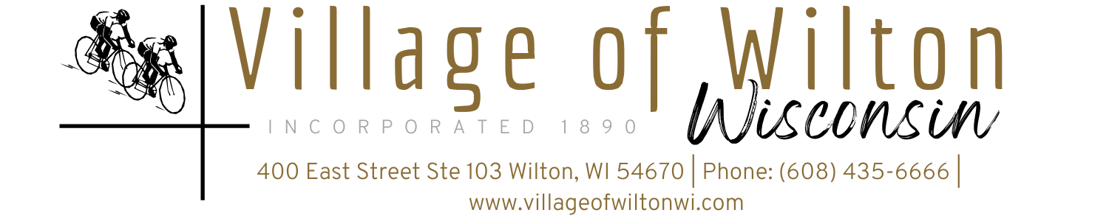

Pursuant to Section 19.84, Wisconsin Statutes, notice is hereby given to the public by the Village President, that the following meeting will be held:

Meeting: | Village Board of Wilton Special Meeting | Date: | Tuesday, September 2, 2025
Location: | Village Clerks Office  400 East St Suite 103 | Time: | 6:00 PM

AGENDA
- Call to Order
Meeting was called to order by President Wilde at 6:00pm

- Roll Call
Members present O’Rourke, Thompson, Coldren, Wilde, Bever, Short, and Wallman

New Business (Items are for discussion and possible action)

Picnic License for Wilton Weenie Days September 6th

Motion by Wallman, second by Short to approve the picnic license for Wilton Weenie Days, September 6th, 2025. Motion carried 7-0

Changes to surface of Softball field per school request

Motion by Wallman, Second by Bever to approve the application of Quickpitch to the Softball field instead of resurfacing the field. Motion carried 7-0

Update on Former Clerk’s plea hearing

Officer Stavlo updated the board on the Plea that was taken at the Aug 28th plea hearing, Sentencing is set to take place November 17, 2025

- Adjourn
Motion by Bever, Second by Short to adjourn at 6:48pm

Mindy Haase – Clerk Treasurer

Agenda posted in accordance with all Wisconsin State Statutes

