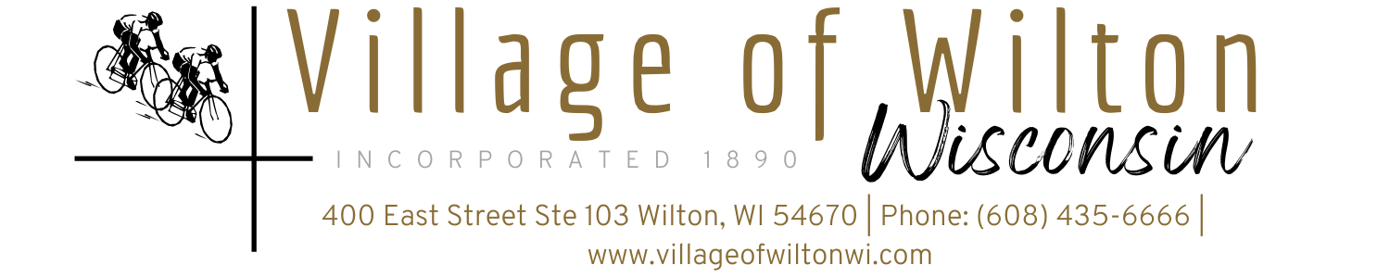

Pursuant to Section 19.84, Wisconsin Statutes, notice is hereby given to the public by the Village President, that the following meeting will be held:

Meeting: | Regular Village of Wilton Board Meeting | Date: | Monday, January 13, 2025
Location: | Village Clerk Office  400 East Street Suite 103 Wilton, WI | Time: | 7:00 PM

AGENDA
A. Call to Order
B. Roll Call
C. Reports of Village Board
a) President’s Report
b) Village Board Comments
c) Village Staff Comments

D. Consent Agenda
a) Bills for the month of December 2024
b) Approval of Minutes

E. Public Comments

F. Discussion & Possible Action on Following New Business Agenda Items:
a) Pay Request No. 18 for WWTF Items
b) Closing of Water & Sewer accounts
c) Vierbicher STH 71 Agreement
d) Cemetery Mowing Bids
e) Operator’s License- Rebecca Hahn, BillieJo Brown, Kathleen Chadwick
f) Wilton Weenie Days Picnic License- 2/7/25
g) 8x7 Rollup Door installed by NOW School in Garage
h) 2025 Election Worker

G. Adjourn

Mindy Haase – Clerk Treasurer

Page 1 of 1
Agenda posted in accordance with all Wisconsin State Statutes

