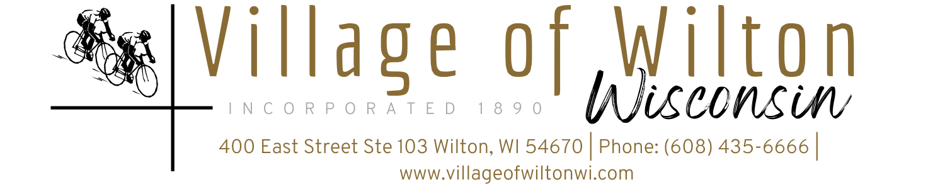

Pursuant to Section 19.84, Wisconsin Statutes, notice is hereby given to the public by the Village President, that the following meeting will be held:

Meeting: | Village Board of Wilton Special Meeting | Date: | Monday, June 23, 2025
Location: | Village Clerks Office  400 East St Suite 103 | Time: | 6:00 PM

AGENDA
- Call to Order
Meeting was called to order by Village President Ed Wilde at 6:00pm

- Roll Call
Members Present O’Rourke, Thompson, Coldren, Wilde, Bever, Short, Wallman

New Business (Items are for discussion and possible action)

Campground lighting repairs

Motion by Coldren, second by Short to approve the estimate from Scott Lind to make the repairs needed for the installation of new lights at the campground for $1379.25

CMAR resolution

Motion by Wallman, second by Bever to approve Resolution 25-01 for the CMAR report

Firework Permit for Wilton Weenie Days

Motion by Bever, second by O’Rourke to approve a firework permit for Wilton Weenie Days July 11th

- Adjourn
Motion by Wallman, second by Coldren to adjourn at 6:51

Mindy Haase – Clerk Treasurer

