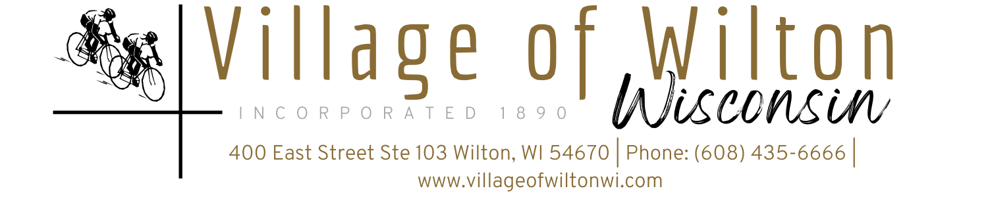

Pursuant to Section 19.84, Wisconsin Statutes, notice is hereby given to the public by the Village President, that the following meeting will be held:

Meeting: | Village Board of Wilton Special Meeting | Date: | Tuesday, September 2, 2025
Location: | Village Clerks Office  400 East St Suite 103 | Time: | 6:00 PM

AGENDA
- Call to Order

- Roll Call

New Business (Items are for discussion and possible action)

Picnic License for Wilton Weenie Days September 6th

Changes to surface of Softball field per school request

Update on Former Clerk’s plea hearing

- Adjourn

Mindy Haase – Clerk Treasurer

Agenda posted in accordance with all Wisconsin State Statutes

